JOURNAL REHABILITÁCIA
--
LCRH

ISSN 0375 – 0922 www.journal.rehabilitacia.sk

(SK) We will translate your title from English to Slovakian native language.

(EN) The title should be placed here, capitalizing only the first letter of the sentence.

¹Name FAMILY NAME, ^{1,2}Name FAMILY NAME, ^{3*} Name FAMILY NAME.

¹(Example)Comenius University in Bratislava. Faculty of Science, Department of Physical and Theoretical Chemistry, Bratislava, Slovakia.
²(Example)Scuola Superiore Meridionale. University of Naples Federico II. Naples, Italy.
³Affiliation (workplace) of the last author in the format: Institution. Faculty/Department/Institute, City, Country.

*Corresponding author: your@email.com

SUMMARY/ABSTRACT (does not exceed 250 words) |  | KEYWORDS
Starting point: Text text text text text text text text text text text text text text text text text text. Text text text text text text text text text text text text text text text text text text. Text text text text text text text text text text text text text text text text text text. Text text text text text  Group: Text text text text text text text text text text text text text text text text text text. Text text text text text text text text text text text text text text text text text text. Text text text text text text text text text text text text text text text text text text. Text text text text text text text  Methods: Text text text text text text text text text text text text text text text text text text. Text text text text text text text text text text text text text text text text text text. Text text text text text text text text text text text text text text text text text text. Text text text text text  Results: Text text text text text text text text text text text text text text text text text text. Text text text text text text text text text text text text text text text text text text. Text text text text text text text text text text text text text text text text text text. Text text text text text  Conclusions: Text text text text text text text text text text text text text text text text text text. Text text text text text text text text text text text text text text text text text text. Text text text text text text text text text text text text text text text text text text. Text text text text text text text.  **The German version of the abstract is attached at the end of the text. |  | word1, word2, word3.  DOI: 10.61983/lcrh.XXXX

INTRODUCTION
The alignment of all texts is JUSTIFY, so that the text is stretched from left to right as this red text is formatted (justify type, Word). Single-sentence paragraphs do not make sense, paragraphs must describe comprehensive information. The text must not be redundant (repeated) or copied without citation. The highest quality of writing also points to quality results that the scientific community around the world will be able to read afterwards.

GROUP AND METHODS
The alignment of all texts is JUSTIFY, so that the text is stretched from left to right as this red text is formatted (justify type, Word). Single-sentence paragraphs do not make sense, paragraphs must describe comprehensive information. The text must not be redundant (repeated) or copied without citation. The highest quality of writing also points to quality results that the scientific community around the world will be able to read afterwards.

STARTING POINT, OBJECTIVE, TASKS
The alignment of all texts is JUSTIFY, so that the text is stretched from left to right as this red text is formatted (justify type, Word). Single-sentence paragraphs do not make sense, paragraphs must describe comprehensive information. The text must not be redundant (repeated) or copied without citation. The highest quality of writing also points to quality results that the scientific community around the world will be able to read afterwards.

RESULTS
The alignment of all texts is JUSTIFY, so that the text is stretched from left to right as this red text is formatted (justify type, Word). Single-sentence paragraphs do not make sense, paragraphs must describe comprehensive information. The text must not be redundant (repeated) or copied without citation. The highest quality of writing also points to quality results that the scientific community around the world will be able to read afterwards.

SUB-CHAPTER HEADING, WE WRITE EVERYTHING IN CAPITAL
The alignment of all texts is JUSTIFY, so that the text is stretched from left to right as this red text is formatted (justify type, Word). Single-sentence paragraphs do not make sense, paragraphs must describe comprehensive information. The text must not be redundant (repeated) or copied without citation. The highest quality of writing also points to quality results that the scientific community around the world will be able to read afterwards.

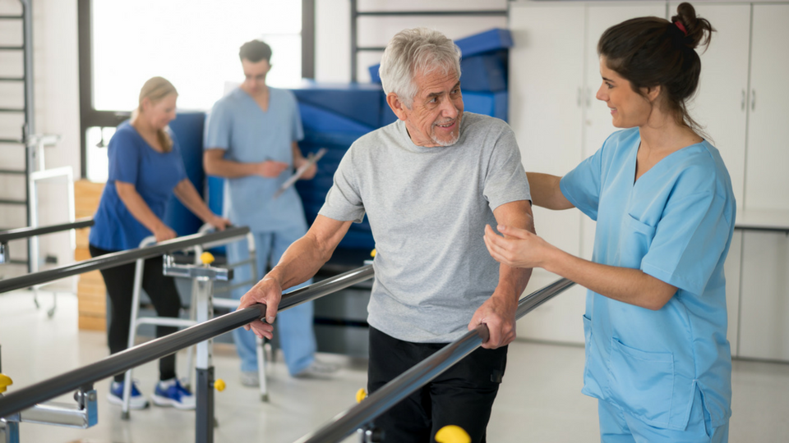
Figure 1 – The description of the image is given below the image. Figures must be uploaded also separately as TIFF files. The resolution of images uploaded separately must be 200 DPI. The text size is set to 10. If the image is not your original, it must be stated (source: XXXXXXXX)

!!!!!!!! Image should be inserted in the text body but must not be the last object at the end of the chapter. After inserting the image, if there is no text after, it is necessary to write at least one paragraph on at least two lines under image. The second option is to place the image so that it is within the body of the text and not at the end of the chapter. It is common practice not to include images at the end of a chapter. A chapter must always end with a text.

DISCUSSION
The alignment of all texts is JUSTIFY, so that the text is stretched from left to right as this red text is formatted (justify type, Word). Single-sentence paragraphs do not make sense, paragraphs must describe comprehensive information. The text must not be redundant (repeated) or copied without citation. The highest quality of writing also points to quality results that the scientific community around the world will be able to read afterwards.

Table 1 - The description of the table is located above the table. The text size is always 10. The table should have a scientifically structured and internationally recognized form, with the number of columns being a maximum of 5 and the number of rows being a maximum of 10. Prefer to use a black and white color scale (including gray).
Groups | Data column | Data column | Explanation, note
Group 1 | 65.22 ± 0.03 | Red | Write an explanation here if necessary
Group 2 | 61.22 ± 0.03 | Blue
Reference group 1 | 11.3 (p<0.05) | Red | Write an explanation here if necessary
Reference group 1 | 16.7 (p<0.05) | Blue

!!!!!!!! Table should be inserted in the text body but must not be the last object at the end of the chapter. After inserting the table, if it is no longer followed by text, it is necessary to write at least one short paragraph of at least two lines. It is common practice not to include tables at the end of the chapter. A chapter must always end with a text.

CONCLUSIONS
The alignment of all texts is JUSTIFY, so that the text is stretched from left to right as this red text is formatted (justify type, Word). Single-sentence paragraphs do not make sense, paragraphs must describe comprehensive information. The text must not be redundant (repeated) or copied without citation. The highest quality of writing also points to quality results that the scientific community around the world will be able to read afterwards.

ZUSAMMENFASSUNG (SUMMARY/ABSTRACT IN GERMAN LANGUAGE)
This summary must be identical to the summary written in English at the beginning of the document. The goal is to bring your article to the widest possible scientifical audience.

SUPPLEMENTARY
- This chapter does not need to be present in the article if you have already included figures and tables in the text.
- Tables.
- Diagrams, graphs, and images, these can be mentioned directly in the text. This point is up to your choice.

REFERENCES

Bertin, M., Atanassova, I. (2022). "Semantic Enrichment of Scientific Publications". Journal Name. 18 (7/8). pp101-172. doi:10.1045/XXXXXXX. ISSN 1082-9873.
Furka, D., et al. (2021). "Article Title". Journal Name. 18 (7/8). pp101-172. doi:10.1045/XXXXXXX. ISSN 1082-9873.

